# Automated Testing Exercise Book

# Introduction

For each of the following websites create a separate project, push these to your GitHub regularly so that I can review your progress. Work through each project in turn. Start working through these exercises in order. The last few exercises will require you to understand DDT, Reporting and the POM. Do not attempt these exercises unless you understand the tasks requested.

# Beginner Tasks

## Task 1 – The Demo Site

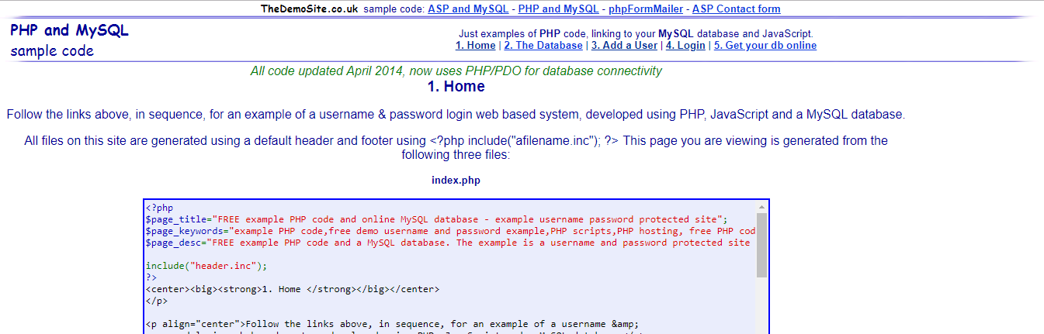

<http://thedemosite.co.uk/>

With this website you can Add a user to the website and then Login as that user, via the links at the top of the website.

Create a user, and subsequently log in with that user, assert that it was successful.

The website only stores one user and password at a time so you must be quick in your automation.

## Task 2 - Shopping Website

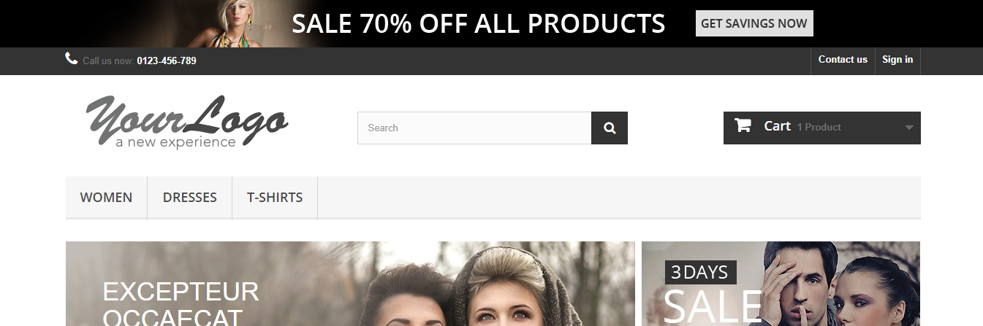

<http://automationpractice.com/index.php>

This website emulates a generic shopping website, think about the features that such a user might need from a website.

Write a test that will search the website for an item of clothing (e.g ‘Dress’) and assert that a particular item was found. There are multiple ways you can do this, do whatever you feel is most appropriate. As a bonus task, take the found item through the checkout system. You will need to create an account to complete checkout.

## Task 3 - PHP Travels

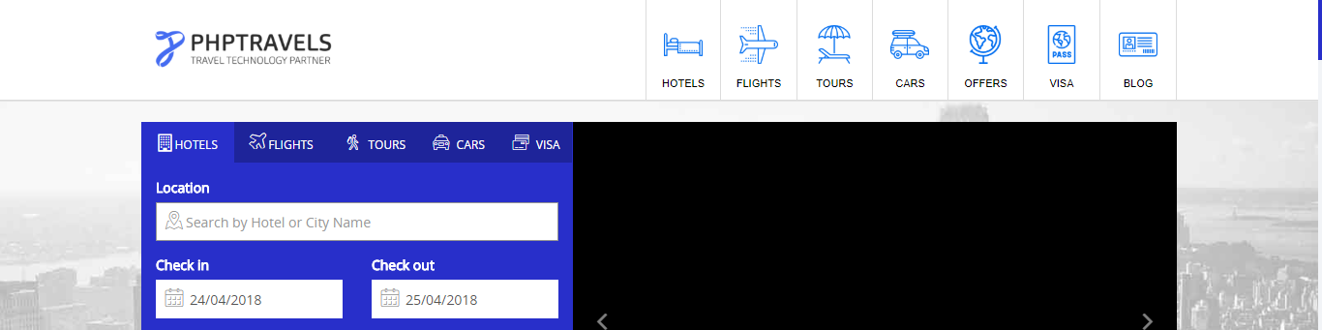

<https://www.phptravels.net/>

This website is particularly difficult to automate, it has not been built with ease of automation in mind. If you encounter any issues think of all the tools and technologies that you have been exposed to within this course. As with all automation of user stories, you should do a dry run manually, and observe the nuances of the system before automating.

Create a test that books a hotel in London for 3 people for 2 nights. Assert that this test has been successful.

## Task 4 – FTSE 100

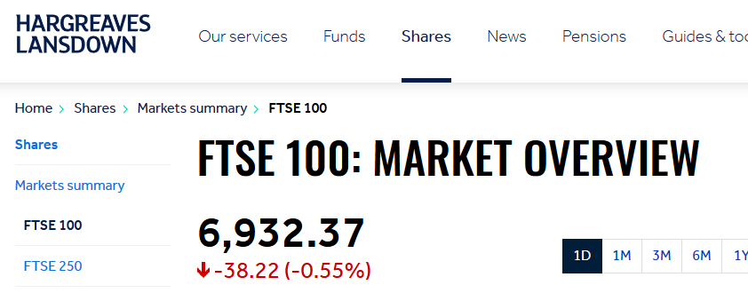

<https://www.hl.co.uk/shares/stock-market-summary/ftse-100>

Using the FTSE 100 market overview, find the largest riser and faller for the latest stock price index. HINT: You should notice that you will not be able to use xpath effectively.

## Task 5 – Mercury Tours

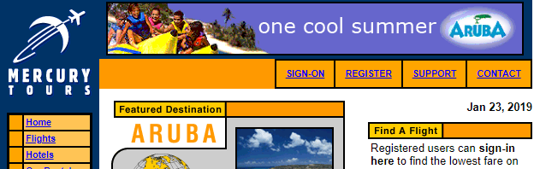

http://www.newtours.demoaut.com/

Using the Mercury Tours website, automate registering an account, and then validate that the created account can sign on. After logging in with the created account, use the flight finder page to find flights from London to Paris for 2 people, in first class, using Unified Airlines as the airline. In the displayed results, select the cheapest flight, and continue all the way through checkout.

# Intermediate Tasks

## Task 6 – Shopping Website

**Reporting**

Add a report to your Shopping Website test.

**Data Driven Testing**

Using Apache POI incorporate a spreadsheet of your own design that contains user details that will be used to automate creating an account on the Shopping Website. Once you have done this write the result of the test to the same spreadsheet.

## Task 8 – PHP Travels

**Reporting**

Add a report to your PHP Travels test.

**Data Driven Testing**

Use DDT to supply the location, check in, check out and people travelling, and book a hotel.

## Cucumber Tasks

## Task 9 - Passionate Tea

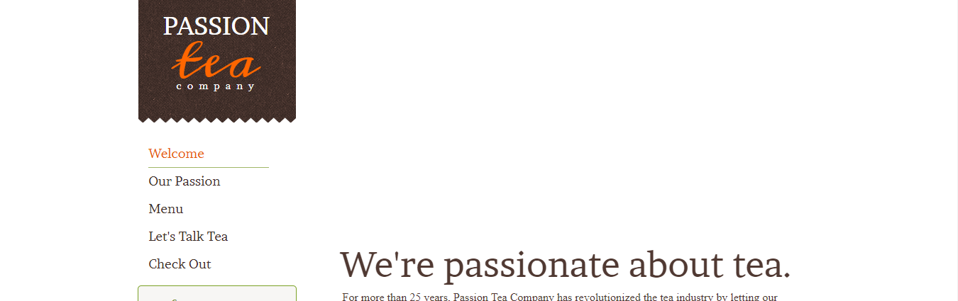

<http://www.practiceselenium.com/welcome.html>

This is a very basic website with only a few pages, the forms have no feedback once they have been completed, this makes the site quite straightforward to use.

Use the supplied feature file (TeaTesting.feature), to write a step definition file to test this website. Do not alter the feature file in anyway.

Feature File content;

*Feature: Shopping on a website*

*As a person*

*I want to browse items on a website*

*So that I can purchase the items I want*

*Scenario: Browse the items available on the website*

*Given the correct web address*

*When I navigate to the 'Menu' page*

*Then I can browse a list of the available products.*

*Scenario: Add an item to the checkout*

*Given the correct web address*

*When I click the checkout button*

*Then I am taken to the checkout page*